|  |  |
| --- | --- |
| Date | 26 June 2025 |
| Team ID | LTVIP2025TMID39268 |
| Project Name | Hematovision – Advanced Blood Cell  Classification using Transfer Learning |
| Maximum Marks | 4 Marks |

**Ideation Phase Empathize & Discover**

**Empathy Map Canvas:**

An empathy map is a simple, easy-to-digest visual that captures knowledge about a user’s behaviours and attitudes.

It is a useful tool to helps teams better understand their users.

Creating an effective solution requires understanding the true problem and the person who is experiencing it. The exercise of creating the map helps participants consider things from the user’s perspective along with his or her goals and challenges.

**Hematovision**

🧠

**What do they THINK and FEEL?** - Concerned about misdiagnosis or delayed diagnosis of blood-related diseases.

* Desire to support doctors and lab technicians with smarter tools. - Believe that AI can reduce human error in diagnosis. - Worry about the reliability and accuracy of current manual methods. - Feel the need for faster, more accessible healthcare innovations.

👁️ **What do they SEE?** - Pathologists spending hours manually classifying blood cells.

* Delays in receiving lab results.
* High workload in diagnostic labs.- Variations in diagnosis accuracy among professionals. - News and research on AI in healthcare.

👂 **What do they HEAR?**

* Discussions about AI tools assisting radiology and pathology. - Concerns about AI replacing human expertise.
* Encouragement from medical institutions to explore automation. - Feedback from doctors/lab techs about slow processes.
* Buzz around transfer learning models like MobileNetV2 in biomedical

⚠️ **PAINS (Challenges)**

* Limited labeled medical data for training models.

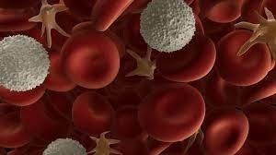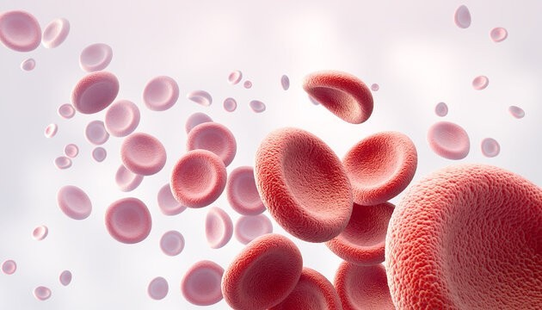

* Skepticism or resistance to AI in medical environments.
* Variability in imaging quality from different sources.
* Need for model explainability for medical adoption.
* Ensuring clinical validation and regulatory compliance.

🎯 **GOALS (Wants/Needs)**

* Achieve faster and more accurate blood cell classification.
* Reduce burden on medical professionals.- Create a scalable, deployable, and costeffective diagnostic tool. - Assist in early disease detection and monitoring.
* Promote adoption of AI in medical diagnostics.

🗣️ **What do they SAY and DO?**

* Express need for scalable diagnostic systems.
* Share opinions on accuracy of AI in healthcare.
* Participate in AI-based research collaborations.
* Recommend tools that can integrate with lab workflows. - Seek innovative ways to improve diagnosis efficiency.